nSSF
A Windows software for the determination of neutron self-shielding correction factors
(Draft) User Guide
Current version: v0.9.2 (Beta)
June 1st, 2017 ( Caracas – Venezuela )
email: fulviofarina@usb.ve
by
F. Farina Arboccò, A. Trkov and C. Chilian

1) The MatSSF open-source (FORTRAN) code was developed by Dr. Andrej Trkov and it is available at the International Atomic Energy Agency (IAEA) website:
https://www-nds.iaea.org/naa/matssf/
The latest version that is bundle to this software dates February 2016
2) The Chilian Sigmoid method was developed by
C. Chilian, G. Kennedy and J. St.-Pierre
Special collaborators: G. Kennedy and H. Barros

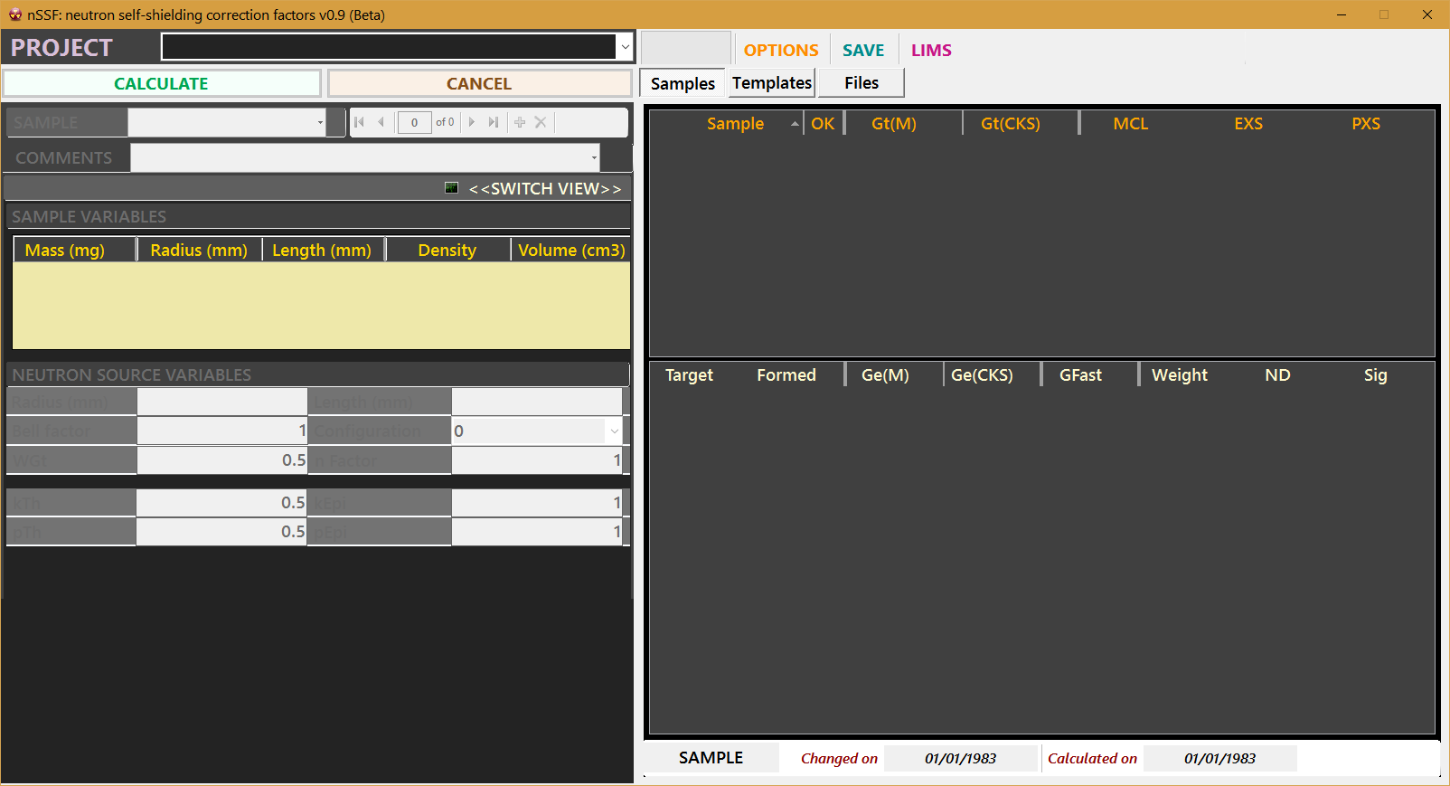

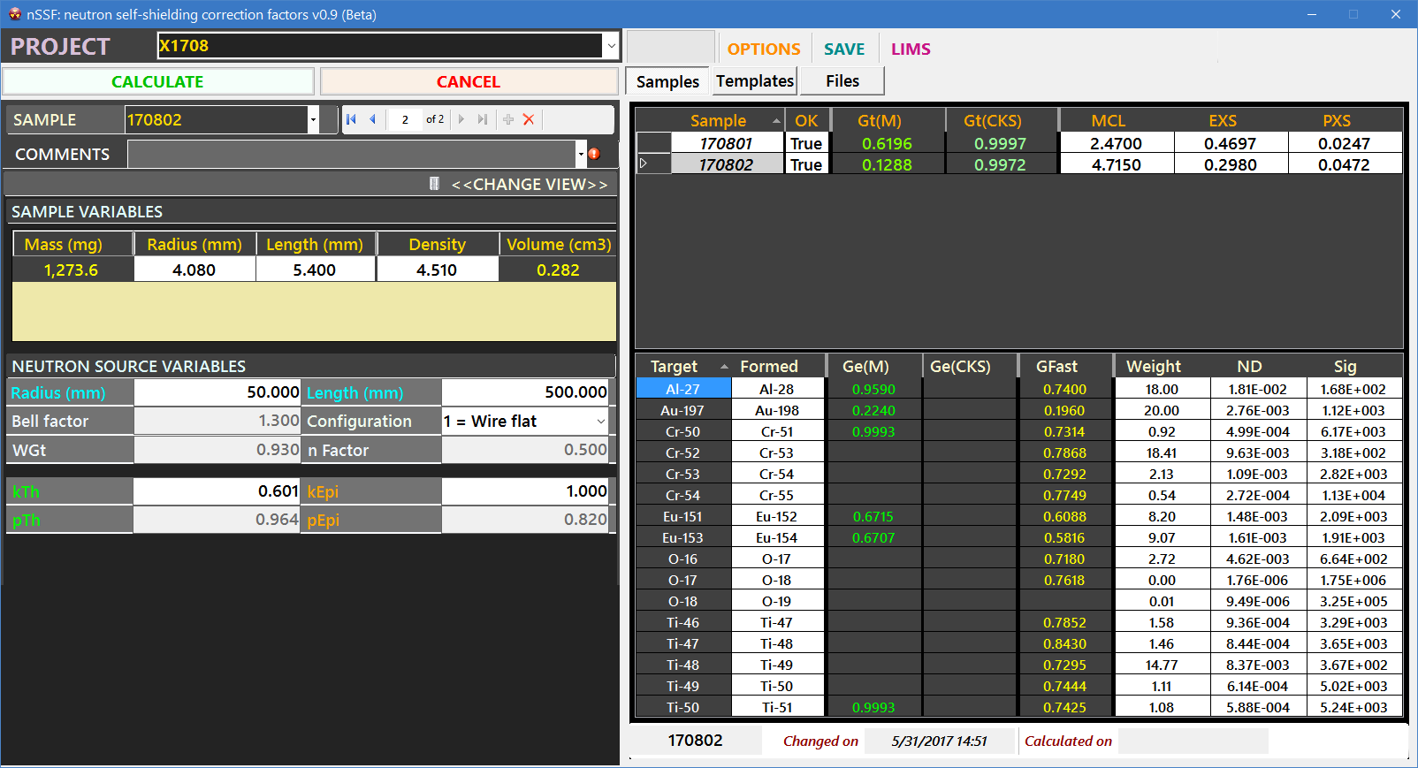

1. Making a project

- In the “Project” box type in the label name of the project you would like to create.
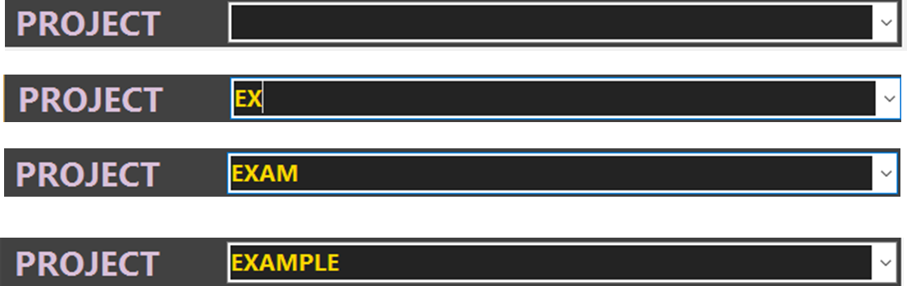
The user could type, for instance:
as a nemonic for project X on the year 2017 and month 6.

- Press ENTER to create the project. A confirmation dialog will appear.
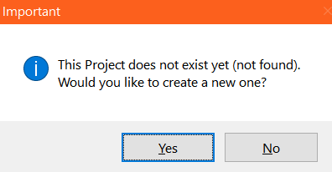

- After clicking YES another confirmation dialog will show up.
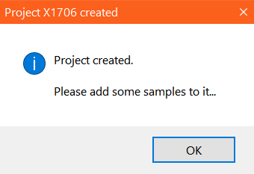

2. Adding samples to a project

- In order to add a sample, employ the yellow Plus (+) Button located in the “Navigation Bar”
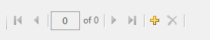
- A new sample is added and its particular sample information is displayed at the application left-hand side panel:

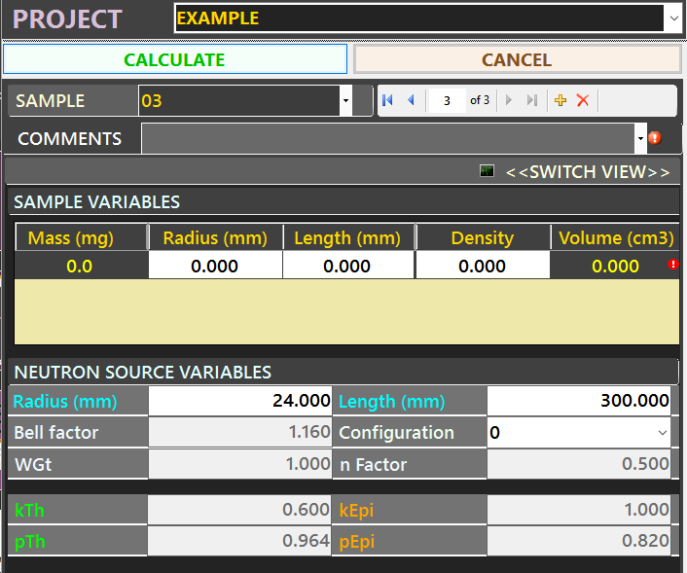
On top you will identify the typical Sample variables for cylindrical samples:
Radius (in mm), Length (in mm), Density (in g/cm³), Mass (in mg) and Volume (in cm³).
A Grey cell indicates that the value is read-only and will be automatically calculated each time each of the White cell parameters are validated.
For instance, the Mass is recalculated each time the Radius, Length or sample Density is modified and validated.

- Type in the desired sample value in a given White cell and press ENTER to validate the value.
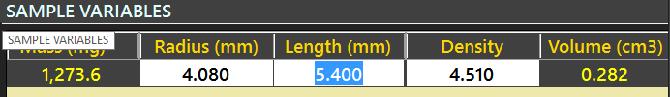

- Add more samples to your project, or delete them with the Delete (X) Button in the Navigation Bar:
These list of samples will appear in the application right-hand panel (see the figure below).
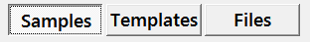
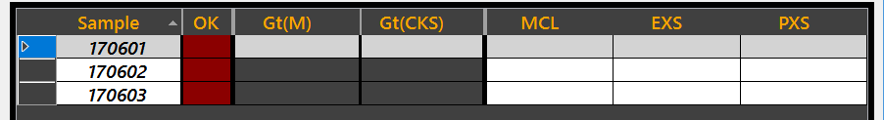

- You can navigate/select which sample you would like to modify by selecting any cell of the respective data row
→
- The composition of a sample (its matrix or list of matrices) can be accesed by the “View” Button

The composition of a given sample is listed in the following grid:
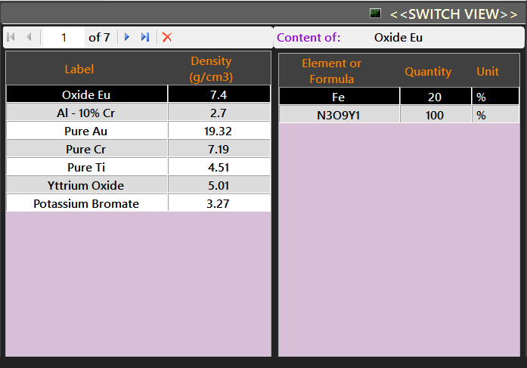

PLEASE REFER TO THE “TEMPLATES” SECTION FOR INSTRUCTIONS ON HOW TO MANIPULATE A SAMPLE COMPOSITION

Important: Preferences Menu

It is possible to change which sample parameter gets automatically recalculated by accesing the “Preferences” menu located in the “Options” menu (see the figure below)
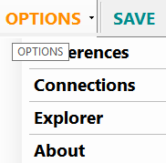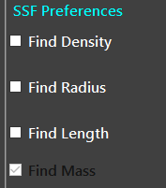

By clicking “Preferences” a pop-up menu will appear. You can choose wether you would like to automatically recalculate the Density, the Radius or the Length of the sample by chekcing these boxes. In order to automatically recalculate the sample Mass, you need to uncheck all these boxes.
Close the Preferences menu.

3. Using the Templates

One of the main ideas of this program is to be able to reuse “Matrices” (or Compositions), “Containers” and neutron “Sources” that are already stored in the database.

- Acces the “Templates” right-panel according to the following figure:
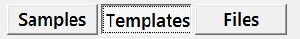
Under this panel you can access 3 different types of Templates.
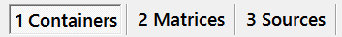

I. Containers

- By selecting “Containers” the user can acces a templates list of different containers to choose.
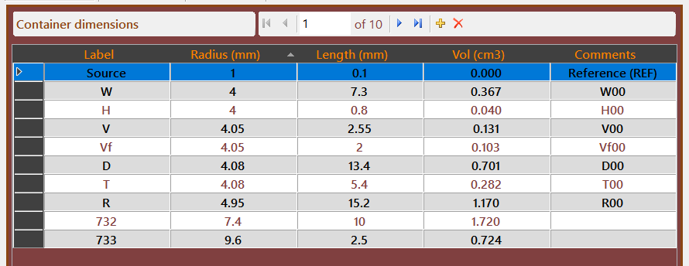

- It is also possible to create more containers with the respective Navigation Bar of the control and, to modify their values by clicking directly into the respective cell to type the new value.

- In order to ASSIGN a container dimensions to the sample, DOUBLE-CLICK on the respective row header of the container
The Radius and Length values of the selected container will replace the Radius and Length values of the sample:
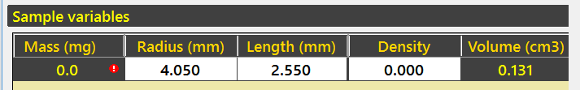

About the links to Templates

If the user later modifies the values of a given template item, these changes will not be automatically propagated to all associated samples.
The template values are only meant to be copied each time the user double-clicks on the respective item. Thus, each sample and its parameters are independent of the template items employed.
Yet, the templates are internally linked in the database (i.e. associated) to the respective sample and in further versions of the program there will be an option to restore the sample parameters to the latest template values associated if the user choses to.

II. Matrices

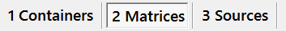

- By selecting “Matrices” the user can acces a template list of different compositions to choose.
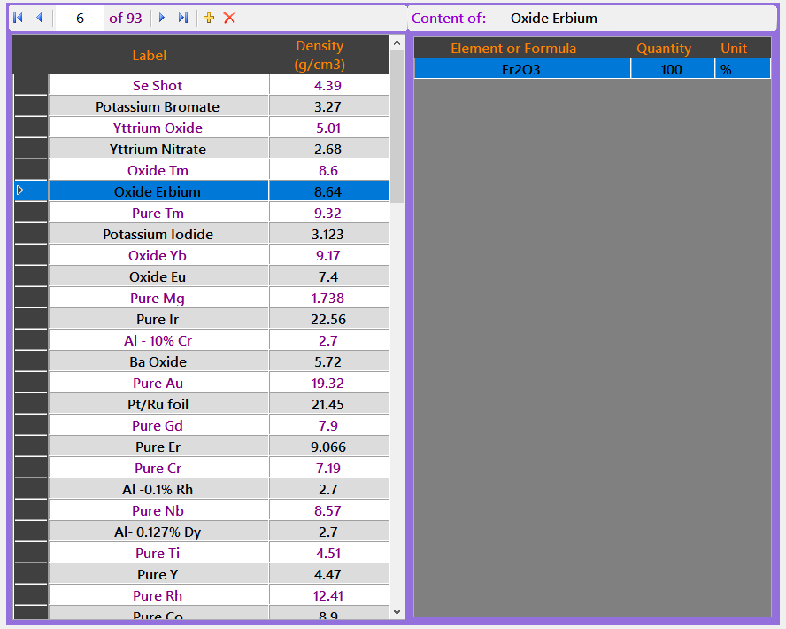
On the left-hand, a list of matrices is shown. Each matrix content can be modified in the right-hand side grid.

Editing a Matrix

- Hover your mouse to the right-hand “Content” grid. The grid will be transformed into a text input box as shown in the figure below:
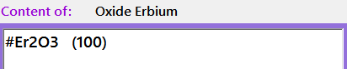

- Type in the matrix content following these strict rules:

#Element (%Content)
or,
#Formula (%Content)

Examples:
#Al (50) #Fe (33.3) #Gd (16.7)
#Al2O3 (20) #Ba1O1 (60) #Mn (20)

Nota Bene: When inputting formulas, the user will need to input explicitly the number “1” that is typically implicit for a given formula. This is not necessary when inputting pure elements.

Examples:
#BaO is incorrect, while #Ba1O1 is correct.
#Fe is correct.

Multi-compound single-Matrix

The program allows for multi-compoun single-Matrices such as e.g. a Monazite mineral:

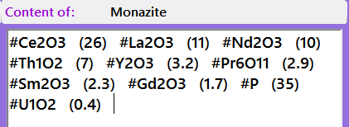

When your mouse leaves the area, the matrix content grid gets updated displaying the new list of compositions (see the figure below).

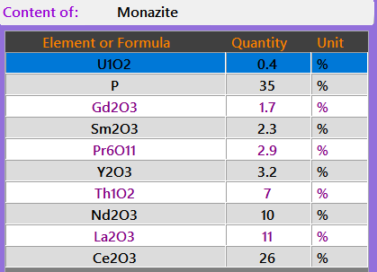

- In order to ADD a (template) matrix to the sample, DOUBLE-CLICK on the respective row header of the item

The matrix is cloned/copied into the list of sample matrices located on the main left panel. The cloned matrix will show up in the “Composition View” as in the following figure:
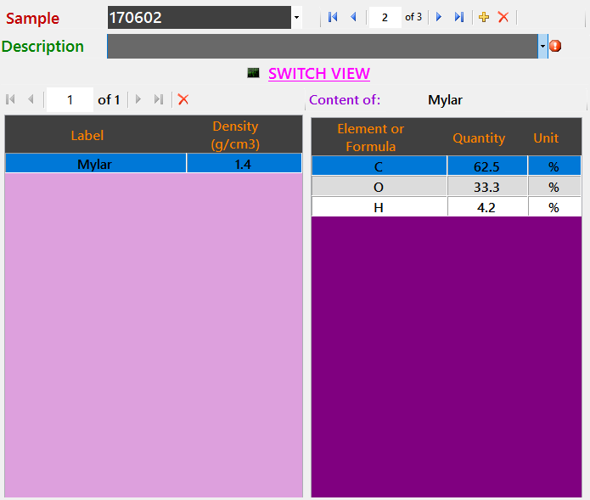

The sample and neutron source panel can be accesed back by clicking on the 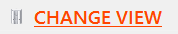 button.
Nota bene: When you adopt the first matrix template, its Density value is copied to the sample Density and the respective Grey cell is recalculated (e.g. the Mass).
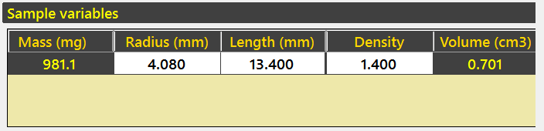

- Modify the content of the sample matrix as in the previous example:
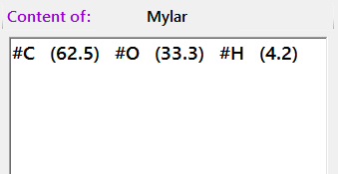

IMPORTANT
You can add to the sample as many clones of template matrices as you want. However, modifying the content of a matrix associated to a sample will not automatically modify the content of a template matrix, and viceversa. Once again, this is to ensure that each sample can be specific and modified at will. Further program versions will allow for the option of restoration of sample values from associated template data if desired.
Still, you can modify the template matrix and re-adopt the updated values into the sample by double-clicking again the row header of the modified template matrix (a manual Matrix UPDATE).

III. Neutron Sources

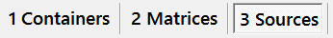
- By selecting “Sources” you can acces a templates list of different neutron sources configurations and dimensions to choose.
On the top grid the user can choose from a list of Neutron source “Configurations” and “Dimensions”, which are basically fixed (fundamental) neutron source parameters for a given neutron source.

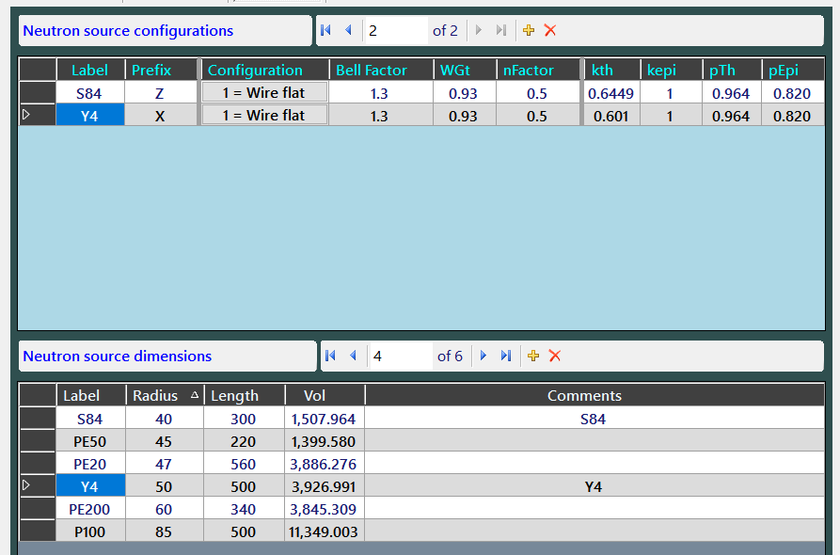

These grids control the “Neutron source parameters” Sample values in the panel located at the left-hand side (see the figure below)
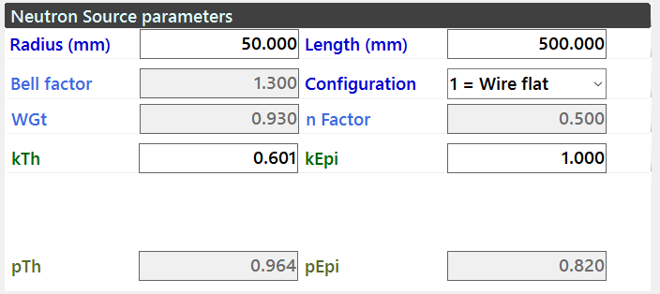

- In order to ASSIGN the (template) neutron source configuration to the sample, DOUBLE-CLICK on the respective row header of the item
For instance, if you select the row “Y4” → 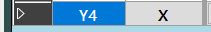
the sample in the left-hand panel will be updated with the incoming values according to the respective calculation method (as shown):

Neutron source configuration

For the MatSSF method

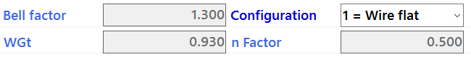

For the CKS method

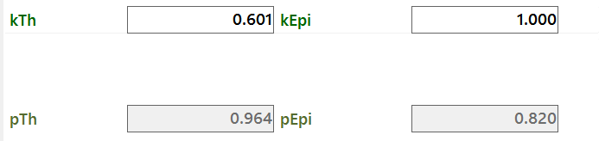

IMPORTANT
The “Prefix” column has a special purpose. If a Project is labelled with a prefix letter present in this template list, each added sample will automatically acquire that neutron source configuration.
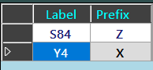

Neutron source dimensions

- In order to ASSIGN the (template) neutron source dimensions to the sample, DOUBLE-CLICK on the respective row header of the item
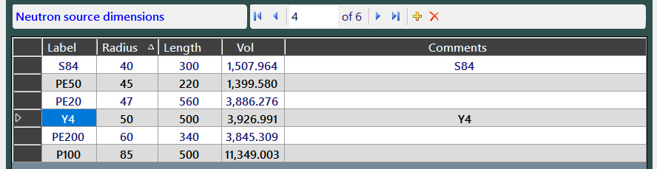
The following sample values in the left-hand panel will be updated with the incoming values:

IMPORTANT
The “Label” column in this grid has a special functionality. If a “Neutron source dimension” label matches a “Neutron source configuration” label, then both template items are linked, and each added sample will automatically acquire that neutron source dimension as well.

4. Calculations

- Once the samples have no visible cell errors as e.g. the figure below, the user can calculate the thermal and epithermal neutron self-shielding correction factors for each sample separatedly or, in batches.
- Click the 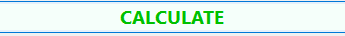 button to start the calculations.
- When the calculations start, the sample status turns Yellow/Orange. the samples that were rejected from the calculation process remain Red and an error message is attached to their sample label (see the figure below).
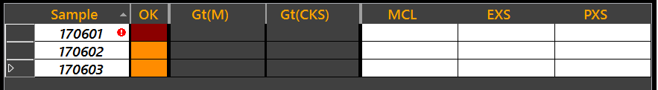
- When calculations are finished, the thermal neutron self-shielding correction factors are displayed and the sample status becomes Green (see the figure below).
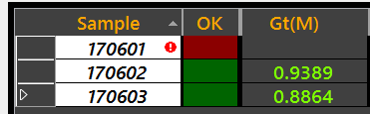

- To display the epithermal neutron self-shielding correction factors select the sample of interest →
The bottom grid will be updated with the respective sample values for each reaction of interest.
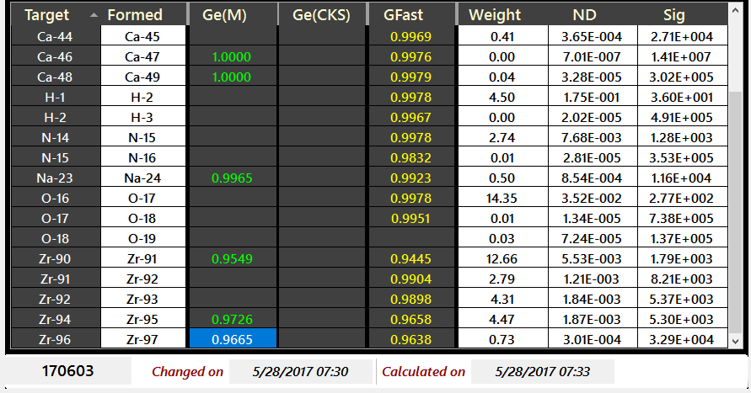
- Select for instance another sample, the bottom grid is automatically updated showing the values for that sample.
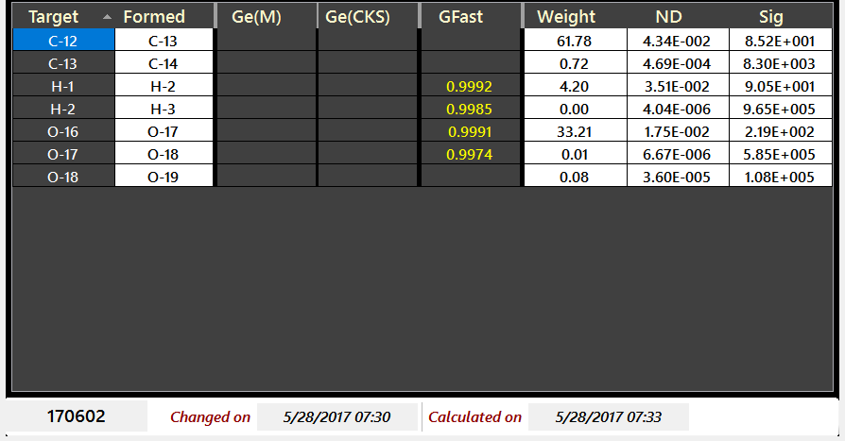

5. Parameters of the Methods

The top grid will also display overall sample results from the calculations, i.e.:
- Gt(M) refers to the Thermal neutron self-shielding correction factor according to the MatSSF method. ^{[1,2]}
- On the other hand the Gt(CKS) value refers to the Thermal neutron self-shielding correction factor according to the Chilian-Kennedy Sigmoid method. ^{[3–6]}
Other parameters
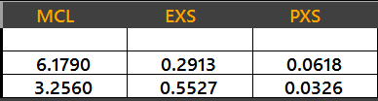
- The MCL corresponds to the Mean-chord length (in cm).
- The EXS value corresponds to the Escape cross-section (in cm⁻¹).
- The PXS value corresponds to the Potential cross –section (in cm⁻¹).

The bottom sample grid on the right-hand side panel will show the sample specific results for the formed nuclei (available in the library):
- Ge(M) refers to the Epithermal and GFast(M) refers to the Fast neutron self-shielding correction factors according to the MatSSF method. ^{[1,2]}
- On the other hand the Ge(CKS) value refers to the Epithermal neutron self-shielding correction factor according to the Chilian-Kennedy Sigmoid method. ^{[3–6]}
- The ND value corresponds to the Nuclei or Isotope Density (in 10²⁴ i.cm⁻³).
- The Sig value corresponds to the Macroscopic cross-section (in barns).
- The Weight corresponds to the % content of a given isotope in the sample.
Other sample information is available on the bottom of this panel, as shown below:

Methods semi-empirical parameters
On the top grid (see figure below), each paramater corresponds to a given calculation method:
MatSSF method:
- Bell Factor:
- nFactor:
- WGt:
- Configuration:

CKS method:
- kth:
- kepi:
- pTh:
- pEpi:

